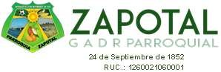

|  |  |  |  |
| --- | --- | --- | --- |
| **ABRIL** | **RAZON SOCIAL/NOMBRE PROVEEDOR** | **RUC** | **MONTO PAGADO** |
| BUCHEIN QUEVEDO CHEDID STEFANO | 1206328799001 | $ 20,00 |
| SUAREZ DELGADO PAOLO IVANOVICH | 1103038517001 | $ 148,80 |
|  |  | **TOTAL INFIMAS ABRIL** | $ 168,80 |